**A**

**PROJECT REPORT**

**ON**

**ONLINE ELECTRONIC STORE**

SUBMITTED IN

PARTIAL FULFILMENT OF THE REQUIREMENTS FOR THE AWARD OF

THE DEGEREE OF

**BACHELOR OF TECHNOLOGY**

(Computer Science Engineering)

**SUBMITTED TO**

**RAJASTHAN TECHNICAL UNIVERSITY, KOTA**

**GOVT. ENGINEERING COLLEGE BIKANER**



**SUBMITTED BY**

Name of Student University Roll No.

Avishek Kumar 13EEBCS014

**SUPERVISED BY**

Mr. Surendra Singh Choudhary

Asst. Professor (Computer Science)

May 2017

**A**

**PROJECT REPORT**

**ON**

**ONLINE ELECTRONIC STORE**

SUBMITTED IN

PARTIAL FULFILMENT OF THE REQUIREMENTS FOR THE AWARD OF

THE DEGEREE OF

**BACHELOR OF TECHNOLOGY**

(Computer Science Engineering)

**SUBMITTED TO**

**RAJASTHAN TECHNICAL UNIVERSITY, KOTA**

**GOVT. ENGINEERING COLLEGE BIKANER**



**SUBMITTED BY**

Name of Student University Roll No.

Avishek Kumar 13EEBCS014

**SUPERVISED BY**

Mr. Surendra Singh Choudhary

Asst. Professor (Computer Science)

May 2017

**CERTIFICATE**

I hereby certify that the work which is being presented in the B.Tech. Major Project Report entitled **“Online Electronic Store”,** in partial fulfilment of the requirements for the award of the **Bachelor of Technology in Computer Science Engineering** and submitted to the Department of Computer Science Engineering of Govt. Engineering College Bikaner Rajasthan is an authentic record of my own work carried out during a period from **Feb 2017 to Apr 2017** (**8th semester**) under the supervision of **Mr.** **Surendra Singh Choudhary,** **CSE Department**.

The matter presented in this Project Report has not been submitted by me for the award of any other degree elsewhere.

**Signature of Student**

**Avishek Kumar (13EEBCS014)**

This is to certify that the above statement made by the student(s) is correct to the best of my knowledge.

**Signature of Supervisor**

#### Date: Mr. Surendra Singh Choudhar

#### Assistant Professor

#### 

#### Mr. Manoj Kuri

#### HOD

#### Computer Science & Engineering Department

# ACKNOWLEDGEMENT

I would like to place on record my deep sense of gratitude to **Prof. Manoj Kuri, HOD-Dept. of Computer Science Engineering, Govt. Engineering College Bikaner, India** for his generous guidance, help and useful suggestions.

I express my sincere gratitude to **Prof. Surendra Singh Choudhary, Dept. of Computer Science Engineering, Govt. Engineering College Bikaner, Rajasthan, India,** for his stimulating guidance, continuous encouragement and supervision throughout the course of present work.

I also wish to extend my thanks to my friends and family for their insightful comments and constructive suggestions to improve the quality of this Project work.

I am extremely thankful to **Mr. Jaiprakash Bhamu, Principal, Govt. Engineering College Bikaner**, for providing me infrastructural facilities to work in, without which this work would not have been possible.

**Signature of Student**

Avishek Kumar (13EEBCS014)

# ABSTRACT

Project Title: - **Online Electronic Store**

E-commerce is fast gaining ground as an accepted and used business paradigm. More and more business houses are implementing web sites providing functionality for performing commercial transactions over the web. It is reasonable to say that the process of shopping on the web is becoming commonplace.

The objective of this project is to develop a general purpose e-commerce store where electronic items can be bought from the comfort of home through the internet.

Technology and platform used: -

Front End Development: **HTML5, CSS3.**

Scripting language: **JavaScript, PHP.**

Browser Used: **Google Chrome and Internet Explorer.**

Server: **WAMP Server.**

Platform: **Windows 7 Enterprise.**

Database: **MySQL.**

**Table of Contents**

ACKNOWLEDGEMENT i

ABSTRACT ii

List of Tables v

List of Figures vi

Abbreviations vii

1 Introduction 1

2 Literature Review 2

3 Project Design Phase 4

3.1 Analysis Phase 4

3.1.1 Requirement Gathering Phase 4

3.1.3 Problem- Existing System 4

3.1.4 Advantages of the Proposed System 5

3.2 FEASIBILITY STUDY 5

3.2.1 Operational Feasibility 5

3.2.2 Technical Feasibility 5

3.2.3 Economic Feasibility 6

3.3 REQUIREMENT SPECIFICATION 6

3.3.1 Functional Requirements 6

3.3.2 Technical Requirements 6

3.4 TOOLS AND TECHNOLOGY 7

3.5 Design Phase 9

3.5.1 List of Tables with constraints 9

3.5.2 Site Map 11

3.5.3 System Flow Chart 12

3.6 Implementation Phase 14

3.6.1 Screen Layout 14

3.7 Test Cases 25

3.8 Maintenance and Evaluation 28

3.8.1 System Maintenance and future enhancement 28

3.8.2 User Manual 28

4 Conclusion and Future Scope 30

5 References 31

# List of Tables

|  |  |  |
| --- | --- | --- |
| **S. No.** | **Table Name** | **Page Number** |
| 1 | File Extensions and their type | 8 |
| 2 | Database-Ecommerce | 9 |
| 3 | Admin | 9 |
| 4 | Brand | 9 |
| 5 | Cart | 10 |
| 6 | Customer | 10 |
| 7 | Order | 10 |
| 8 | Product | 10 |
| 9 | Categories | 11 |
| 10 | Test Cases: 1 | 25 |
| 11 | Test Cases: 2 | 26 |
| 12 | Test Cases: 3 | 26 |
| 13 | Test Cases: 4 | 27 |

# List of Figures

|  |  |  |
| --- | --- | --- |
| **S. No.** | **Figure Name** | **Page Number** |
| 1 | Site Map | 11 |
|  | **Website** | |
| 2 | Home Page | 14 |
| 3 | Cart page | 14 |
| 4 | Checkout/Login page | 15 |
| 5 | Register Page | 15 |
| 6 | My Account Page | 16 |
| 7 | My Orders Page | 16 |
| 8 | Edit Account Page | 17 |
| 9 | Change Password Page | 17 |
| 10 | Delete Account Page | 18 |
| 11 | Payment Page | 18 |
| 12 | PayUBiz Official Page | 19 |
| 13 | Payment Success | 19 |
| 14 | Payment Failure | 19 |
|  | **Admin-Area** | |
| 15 | Login | 20 |
| 16 | Index Page | 20 |
| 17 | Insert New Product | 21 |
| 18 | View All Product | 21 |
| 19 | Insert New Categories | 22 |
| 20 | View All Categories | 22 |
| 21 | Insert New Brand | 23 |
| 22 | View All Brand | 23 |
| 23 | View Customer | 24 |
| 24 | View Orders | 24 |

# Abbreviations

|  |  |
| --- | --- |
| **Abbreviations** | **Full Form** |
| GVU | Graphics, Visualization and Usability |
| QoS | Quality of Service |
| HDD | Hard Disk Drive |
| RAM | Random Access Memory |
| WAMP | Windows, Apache, MySQL and PHP |
| HTML | HyperText Markup Language |
| CSS | Cascading Style Sheets |
| PHP | Hypertext Pre-processor |
| RDBMS | Relational Database Management System |
| OS | Operating System |
| 3NF | Third Normal Form |

# Introduction

E-commerce is fast gaining ground as an accepted and used business paradigm. More and more business houses are implementing web sites providing functionality for performing commercial transactions over the web. It is reasonable to say that the process of shopping on the web is becoming commonplace.[1]

The objective of this project is to develop a general purpose e-commerce store where electronic items can be bought from the comfort of home through the internet.

An online store is a virtual store on the Internet where customers can browse the catalogue a select products of internet. The selected items may be collected in a shopping cart. At checkout time, the items in the shopping cart will be presented as an order. At the time, more information will be needed to complete the transaction. Usually, the customer will be asked to fill or select a billing address, a shopping address, a shopping option and payment information such as credit card number. An email notification is sent to the customer as soon as the order is placed.[2]

This document is the design report for a web based electronic store. This is mainly about ‘how to do’ and also will help provide an insight to the whole system design and implementation of the online electronic store. This software has the following three main components:

* Implement the different types of users- Administrator and Customer.
* Implement shopping cart for checkout and payment procedures.
* Management of products and orders.

This design document mainly consists of state machine/ Activity flow diagram, class design, internal data structures, architectural design, user interfaces and testing. The main purposes of this design document are listed below.

* Precise understanding of the requirements and constraints related with the programming language, and the user interface.
* System decomposition into manageable units or modules.
* Provide a basic outline of the user interface of the online shopping mall.

This report is the result of the design phase. The class diagrams and activity provide a schematic representation of the various classes used and design flow respectively. The class diagrams also hold the data structures that would be used and also their data types.

The website will be implemented using PHP as the programming Language. MySQL database will be used to store vital user, product and order information.

# Literature Review

Electronic Commerce (e-commerce) applications support the interaction between different parties participating in a commerce transaction via the network, as well as the management of the data involved in the process.[3]

The increasing importance of e-commerce is apparent in the study conducted by researchers at the GVU (Graphics, Visualization, and Usability) Center at the Georgia Institute of Technology. In their summary of the findings from the eighth survey, the researchers report that “e-commerce is taking off both in terms of the number of users shopping as well as the total amount people are spending via Internet based transactions”.

Although the issue of security remains the primary reason why more people do not purchase items online, the GVA survey also indicates that faith in the security of ecommerce is increasing. As more people gain confidence in current encryption technologies, more and more users can be expected to frequently purchase items online.

A good e-commerce site should present the following factors to the customers for better usability.

* Knowing when an item was saved or not saved in the shopping cart.
* Returning to different parts of the site after adding an item to the shopping cart.
* Easy scanning and selecting items in a list.
* Effective categorical organization of products.
* Simple navigation from home page to information and order links for specific products.
* Obvious shopping links or buttons.
* Minimal and effective security notifications or messages.
* Consistent layout of product information.

Another important factor in the design of an e-commerce site is feedback. The interactive cycle between a user and a web site is not complete until the web site responds to a command entered by the user. According to Norman, "feedback--sending back to the user information about what action has actually been done, what result has been accomplished--is a well-known concept in the science of control and information theory.

Imagine trying to talk to someone when you cannot even hear your own voice, or trying to draw a picture with a pencil that leaves no mark: there would be no feedback".

Web site feedback often consists of a change in the visual or verbal information presented to the user. Simple examples include highlighting a selection made by the user or filling a field on a form based on a user's selection from a pull down list. Another example is using the sound of a cash register to confirm that a product has been added to an electronic shopping cart

Completed orders should be acknowledged quickly. This may be done with an acknowledgment or fulfilment page. The amount of time it takes to generate and download this page, however, is a source of irritation for many e-commerce users. Users are quick to attribute meaning to events. A blank page, or what a user perceives to be "a long time" to receive an acknowledgment, may be interpreted as "there must be something wrong with the order." If generating an acknowledgment may take longer than what may be reasonably expected by the user, then the design should include intermediate feedback to the user indicating the progress being made toward acknowledgment or fulfilment.

Finally, feedback should not distract the user. Actions and reactions made by the web site should be meaningful. Feedback should not draw the user's attention away from the important tasks of gathering information, selecting products, and placing orders.

# Project Design Phase

## Analysis Phase

### Requirement Gathering Phase

#### Problem Statement

* Currently the customer/shopkeeper is visiting the shop to buy the products.
* The main problem for the customers/shopkeepers is that it is a time consuming  
  task to visit the shop to buy the products.
* Therefore customer/shopkeeper needs to visit the website, browse for the products  
  of his wish list and place the order accordingly.
* **Limitations of current system in use**
  + Wastage of time in visiting the shop.
  + More efforts to carry the product back to their respective places, if lot of products have to be bought.
  + Difficult to recollect the products needed.
  + More human efforts as all calculation is manual done.

#### Project Objective and Scope of

**Project: Project Objective**

The main objective behind making this website is increase the business, smarter and better.  
The website meets the following objective that retail Store’s needs:

* Faster bill and receipt generation.
* Cutting time in gathering details of product manually.
* Hand written bills hence optimizing the use of page.

**Scope of Project**

At presently this website is support for just placing order and and bill register.  
Further enhancement of the software will have the following features:

* Alerts to customers/shopkeepers of Retail Stores when bill is generated for given order via e-mail.
* A website will allow customer/shopkeepers to pay the bill through online payment option which accept the cash on delivery format.

### Problem- Existing System

Currently the shopkeeper is generating bills on paper. The main problem shopkeeper is facing is that more time is consumed for writing the bill. In case of physical bill there is always possibility of bill getting misplaced or being damaged which leaves the shopkeeper and customer/shopkeepers with no records/ history.

### Advantages of the Proposed System

This website that is developed by us is solving all the problems of the shopping and bill  
generation. We have also kept many options for future enhancement which will benefit the Retail Stores and make the process faster.

## FEASIBILITY STUDY

### Operational Feasibility

* Operational feasibility is to gain an understanding of whether the proposed system will likely to solve the business problems, or take advantage of the opportunities or not. It is important to understand how the new system will fit the current day-to-day operations of the organization.
* We have also conducted an operational feasibility of our system to identify whether our system is able to satisfy the goal of developing the system.
* Before using system, Retail Stores used to work manually and we made a record of the time consumed in the entire process of making the bill, receipt. So as per the requirement of the customer/shopkeeper the developed software could cut down the time consumed and thereby satisfied the one major goal.
* The other major requirement of Retail Stores for which he wanted to develop website is for growth of business. This requirement was also satisfied.
* The next thing was to make a solution to get the product details of previous order from Customer/Shopkeeper. This problem we have solved by hosting a website.
* The next thing Retail Stores needed was a system that is easy to use. So we designed an interface which is extremely easy to use and also we have given attention to website wherein customer/shopkeeper can access the website from computer.

### Technical Feasibility

* Assessing technical feasibility is to evaluate whether the new system will perform  
  adequately and whether an organization has ability to construct a proposed system or  
  not. The technical assessment help answer the question such as whether the technology  
  needed for the system exists, how difficult it will be to build, and whether the firm has  
  enough experience using that technology.
* In case of technical feasibility we have made a system that match accord to the  
  requirements of the accountant.
* We have made the project in a language in which we are familiar. The entire project  
  and website is made in PHP and MySQL Server. We have chosen these to as the project is small and also we are familiar with the technologies.
* The next area where have concentrated is the operating system architecture. At  
  presently the client is using Windows 7 32bit and very soon he is planning to buy a new  
  system after the release of Windows 10 which will be mostly 64bit. So in order to solve  
  this problem we have made the software operating system and architecture friendly.

### Economic Feasibility

* Economic evaluation is a vital part of investment appraisal, dealing with factors that  
  can be quantified, measured, and compared in monetary terms (Chen 1996). The results  
  of an economic evaluation are considered with other aspects to make the project  
  investment decision as the proper investment appraisal helps to ensure that the right  
  project is undertaken in a manner that gives it the best chances of success.
* The system according to us is cost effective as this a small group which is containing  
  little members and only two members are working on this project.
* Since the time given to us almost 10 months we have more time and therefore less man  
  power is required to develop the project.

## REQUIREMENT SPECIFICATION

### Functional Requirements

The software that we are making has the following functional requirement:

* Functions of Website:
* Generating Bill.
* Handling multiple customers/shopkeepers and shop accounts.
* Handling users.
* Backup and Restore facility.
* Admin Functionality:
* Add, edit and remove Customer, Shopkeeper, and Distributer.
* Add, edit and remove Users.
* Add, view and print Bill.
* Backup and Restore data.
* User Functionality.
* View Bill.
* View products and shop for them.

### Technical Requirements

* For running website there are some specification and only if it satisfies the specified  
  requirement it will get installed and works as it is designed for.
* A technical requirement pertains to the technical aspects that your system must fulfil,  
  such as performance-related issues, reliability issues, and availability issues. These  
  types of requirements are often called quality of service (QoS) requirements, service level requirements or non-functional requirements.
* For our software also there are some specification there are as follows:
* Minimum space required in HDD is 200MB.
* RAM required is 1GB.
* Screen resolution should be 1024x768 or more.
* Internet Connection.
* Web browser with latest version or any version that is not old than a year.
* Pen drive or external HDD for safe backup.
* Windows 7, 8.1 or any higher version.
* Works with both 32bit and 64bit Operating System.
* The website will work properly as intended and smoothly only if the  
  requirements are met or else the software will work but it may lag.

## TOOLS AND TECHNOLOGY

The tools that we are using for this software are:

* WAMP SERVER[4]
* WampServer refers to a [software stack](https://en.wikipedia.org/wiki/Solution_stack) for the [Microsoft Windows](https://en.wikipedia.org/wiki/Microsoft_Windows) operating system, created by Romain Bourdon and consisting of the [Apache web server](https://en.wikipedia.org/wiki/Apache_HTTP_Server), [OpenSSL](https://en.wikipedia.org/wiki/OpenSSL) for SSL support, [MySQL](https://en.wikipedia.org/wiki/MySQL) database and [PHP](https://en.wikipedia.org/wiki/PHP) programming language.

Technologies that we have used in our project are as follows: [5]

* HTML
* **H**yper**t**ext **M**arkup **L**anguage, commonly referred to as HTML, is the standard markup language used to create web pages. It is written in the form of HTML elements consisting of *tags* enclosed in angle brackets.
* For creating any website or web application we have the basic thing required  
  is HTML.
* CSS
* **C**ascading **S**tyle **S**heets, fondly referred to as CSS, is a simple design language intended to simplify the process of making web pages presentable.
* CSS classes using which one can develop more interactive websites and  
  web application.
* We have used css classes to make out website look more user attractive, better  
  component stabilization and using this our web application can be viewed in  
  any mobiles or tab
* JavaScript
* JavaScript program runs inside a host environment.
* The web browser is the most common environment, but it is not the only one.
* Using it, we can create all kinds of widgets, application extensions, and other piece of software.
* PHP
* PHP (recursive acronym for PHP: Hypertext Pre-processor) is a widely used open source general purpose scripting language that is especially suited for web development and can be embedded into HTML.
* These are three main areas where PHP scripts are used:
  + Server-Side Scripting.
  + Command Line Scripting.
  + Writing Desktop Applications.
* MySQL
* MySQL is a fast, easy-to-use RDBMS being used for many small and big businesses.
* It is developed, marketed and supported by MySQL AB, which is a Swedish Company.
* It works on many OS and with many languages such as PHP.
* It is very friendly to PHP, the most appreciated language for web development.
* It is customizable.
* Operating System (Windows 7)
* Windows 7 is a personal computer OS developed by Microsoft.

|  |  |
| --- | --- |
| File Extension | Processing Technologies |
| .html | HTML |
| .css | CSS |
| .js | JavaScript |
| .php | PHP |

**Table 1: File extension and their type**

## Design Phase

### List of Tables with constraints

Normalization of Database

Database Normalization is a technique of organizing the data in the database. Normalization is a systematic approach of decomposing tables to eliminate data redundancy and undesirable characteristics like Insertion, Update and Deletion Anomalies. It is a multi-step process that puts data into tabular form by removing duplicated data from the relation tables.

Normalization is used for mainly two purpose,

* Eliminating redundant (useless) data.
* Ensuring data dependencies make sense i.e. data is logically stored.

We have made our data base normalized up to 3 N F.

**Database- Ecommerce**

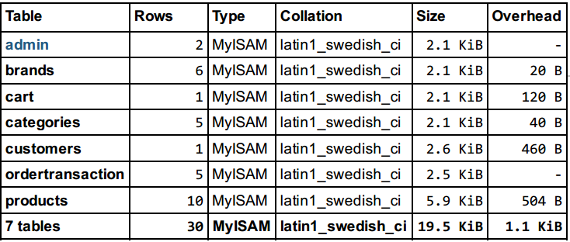

**Table 2: Database- Ecommerce**

**Admin**

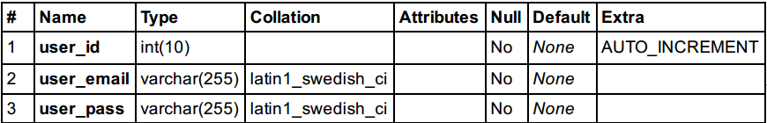

**Table 3: Admin**

**Brand**

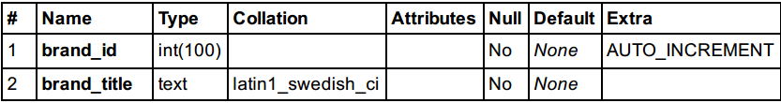

**Table 4: Brand**

**Cart**

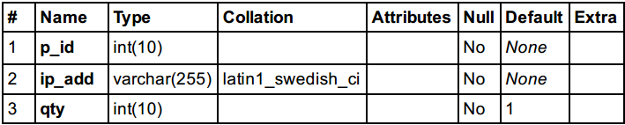

**Table 5: Cart**

**Customer**

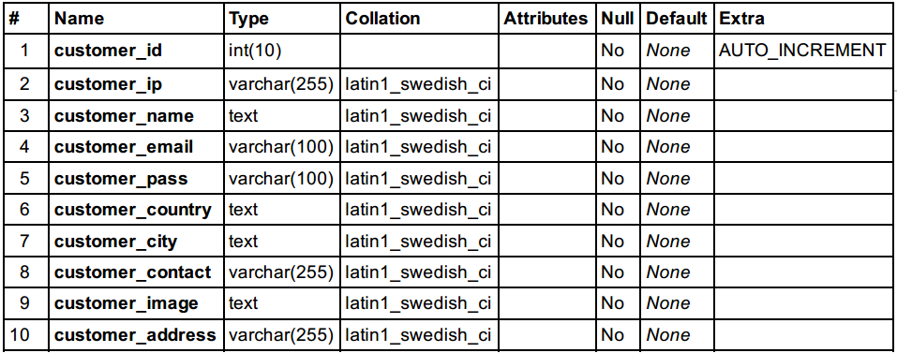

**Table 6: Customer**

**Order**

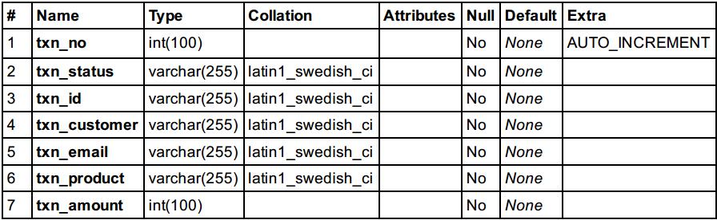

**Table 7: Order**

**Products**

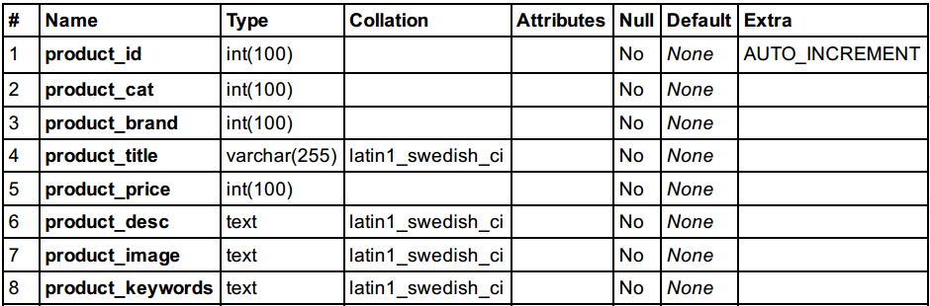

**Table 8: Products**

**Categories**

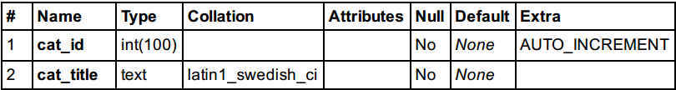

**Table 9: Categories**

### Site Map

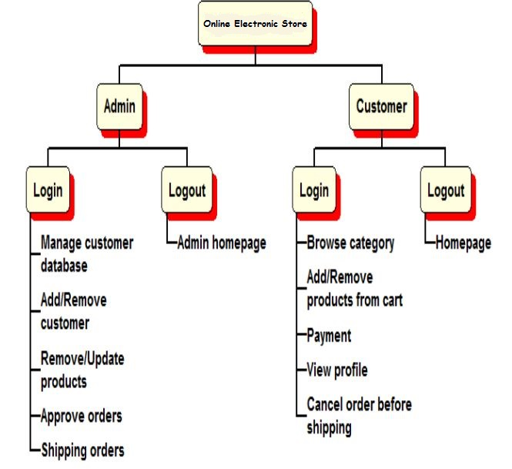

**Fig. 1: Sitemap**

### System Flow Chart

**Admin Flow Chart**

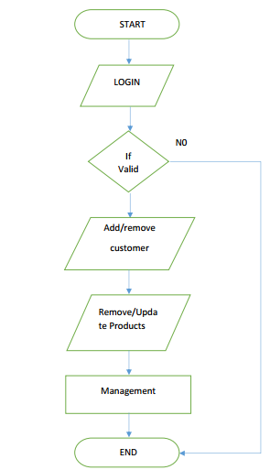

**Admin Flow Chart**

**Customer/Shopkeeper Flow Chart**

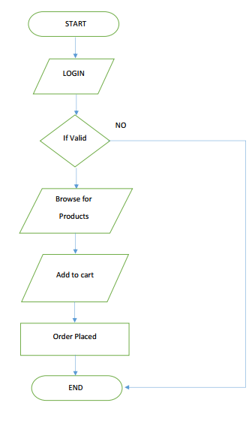

**Customer Flow Chart**

## Implementation Phase

### Screen Layout

**Home Page**

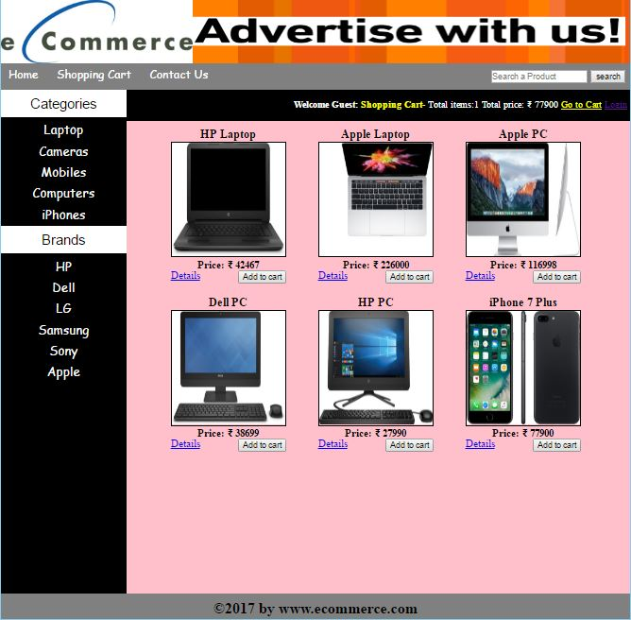

**Fig. 2: Home Page**

**Cart**

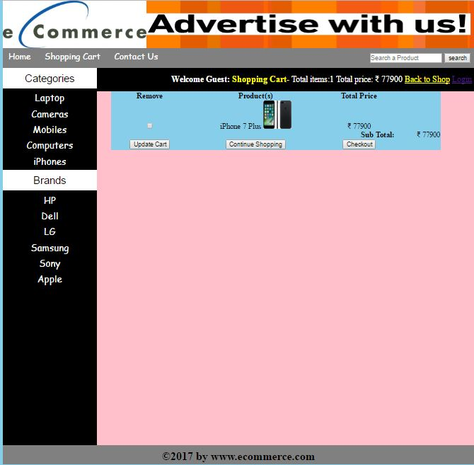

**Fig. 3: Cart Page**

**Checkout/login Page**

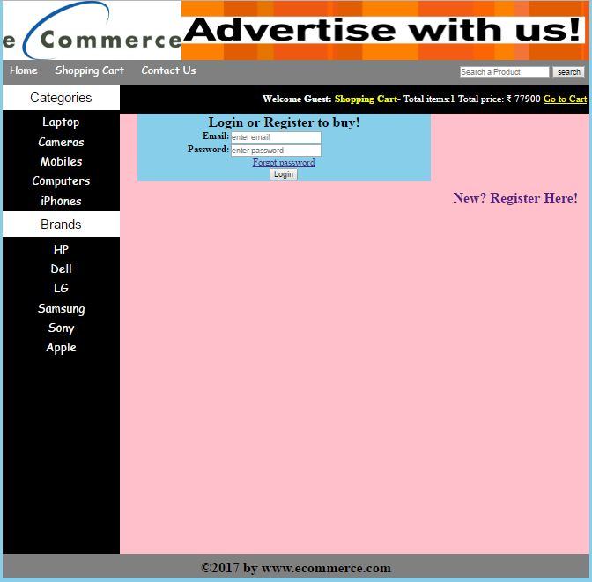

**Fig. 4: Checkout/ Login Page**

**Register**

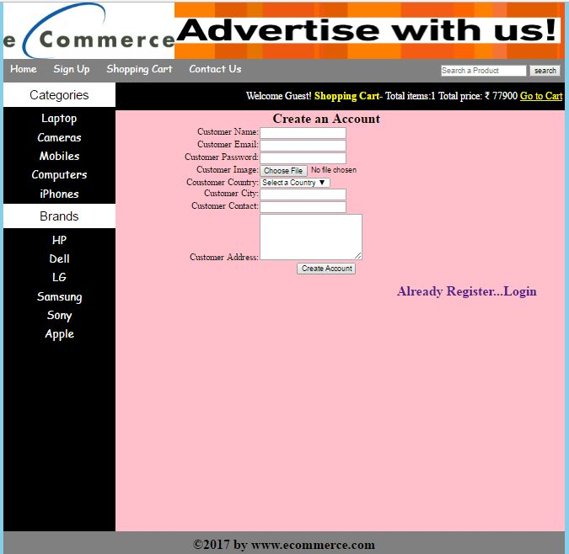

**Fig. 5: Registration Page**

**My Account Page**

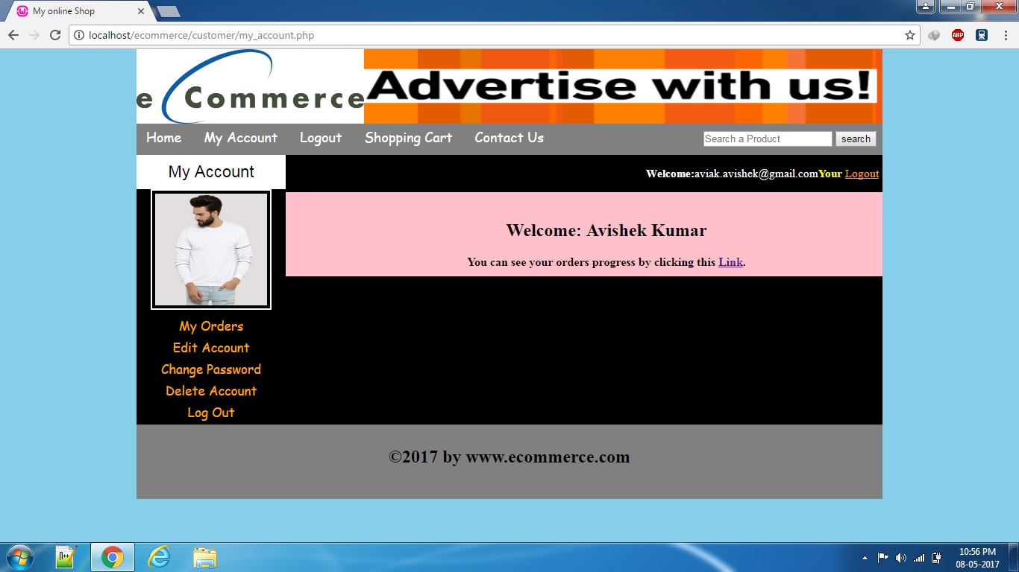

**Fig. 6: My Account Page**

**My Account-Orders**

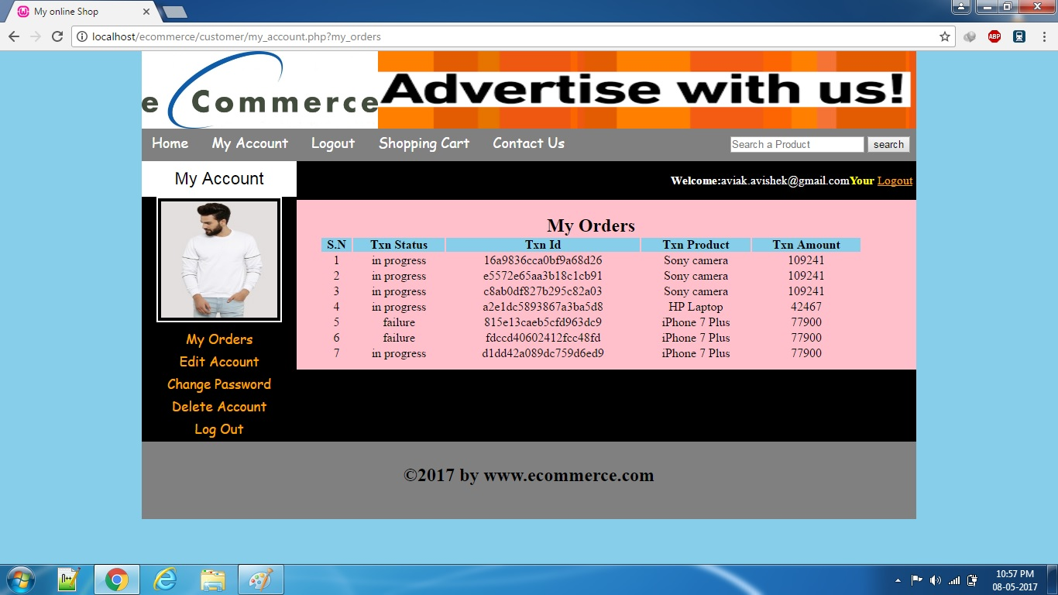

**Fig. 7: My account- My Orders page**

**My Account-Edit Account**

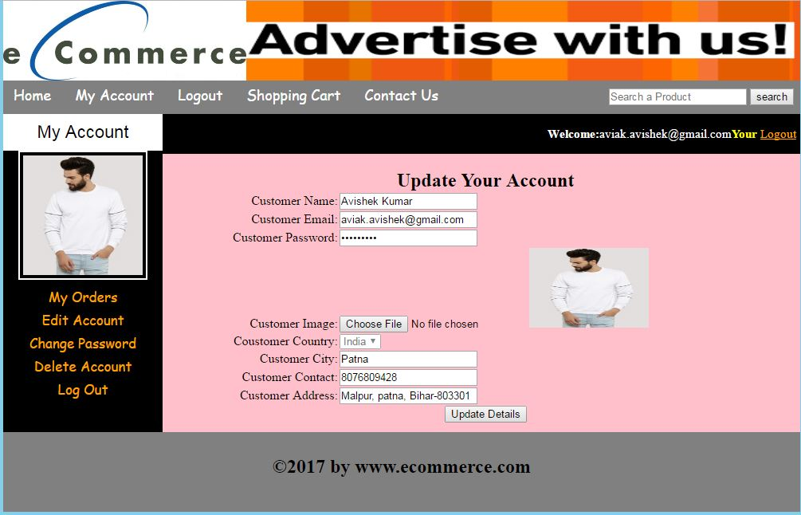

**Fig. 8: My Account-Edit Account**

**My Account-Change Password**

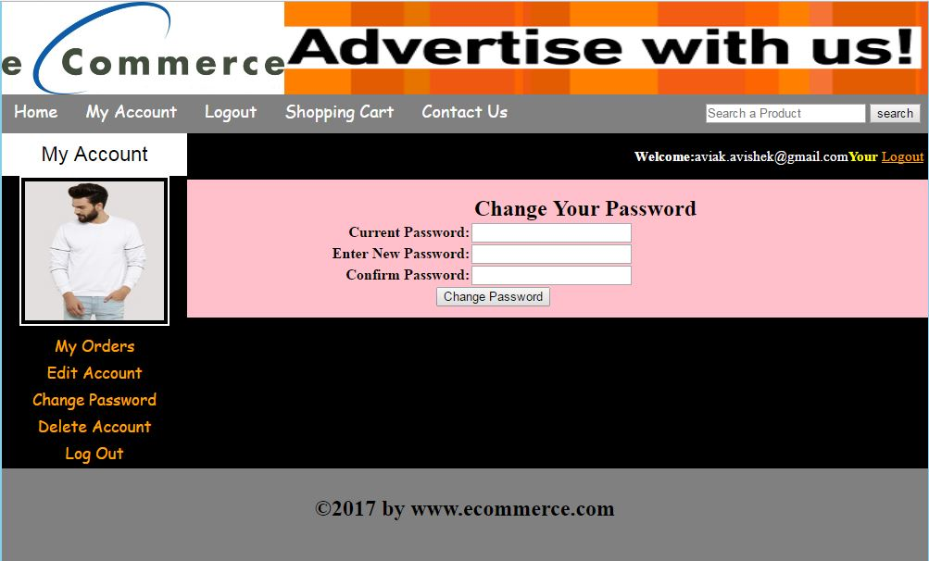

**Fig. 9: My Account-Change Password**

**My Account-Delete Account**

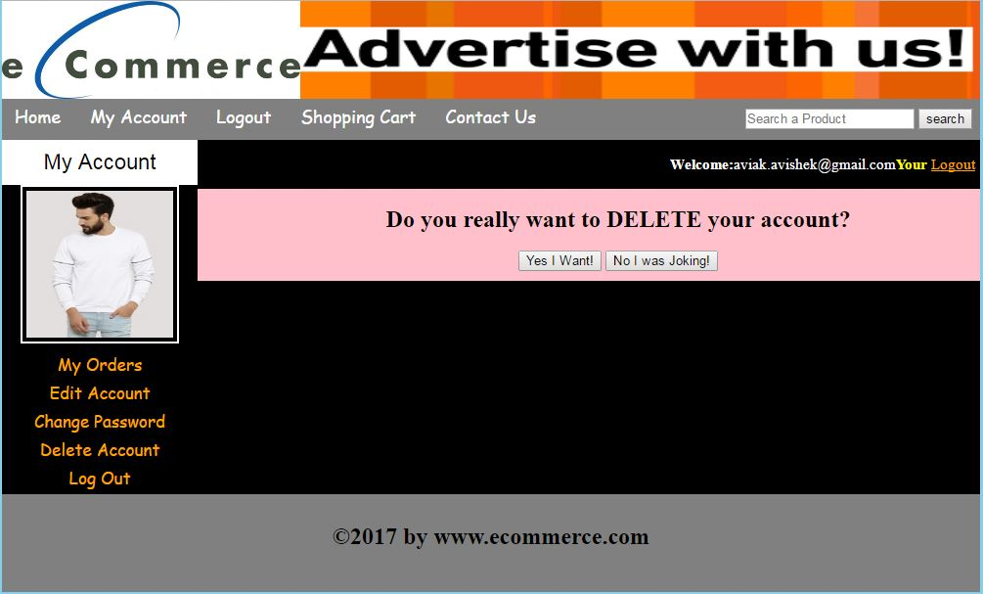

**Fig. 10: My Account-Delete Account**

**Payment**

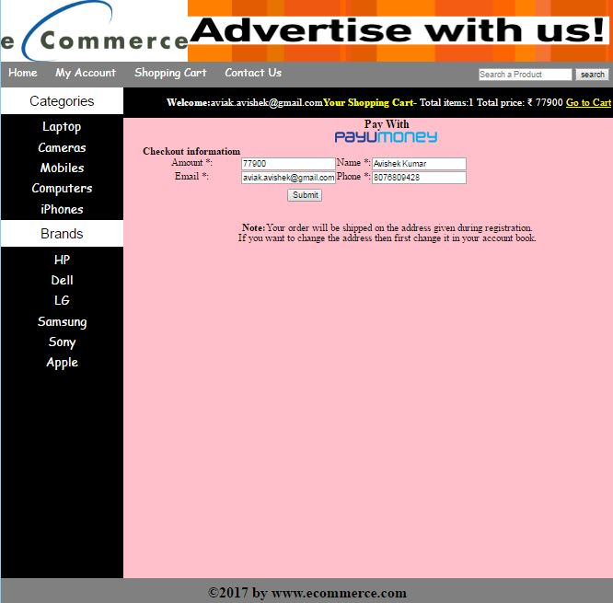

**Fig. 11: Payment Page**

**PayUBiz**

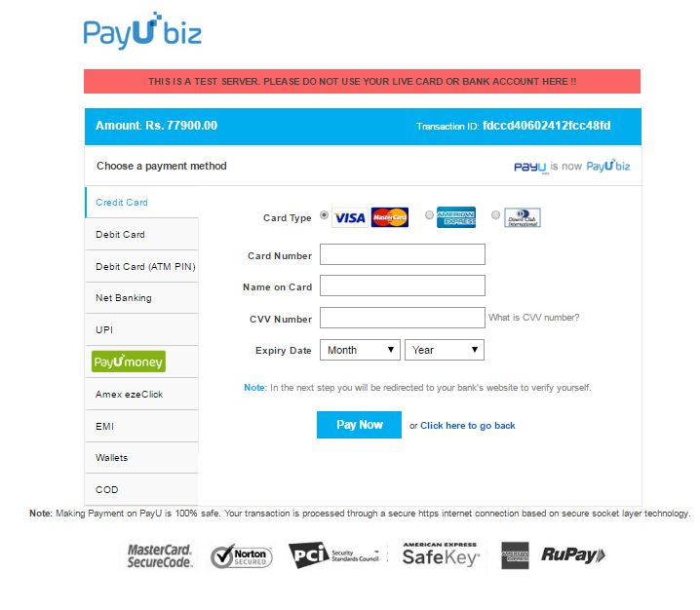

**Fig. 12: PayUBiz Official page**

**Payment Success**

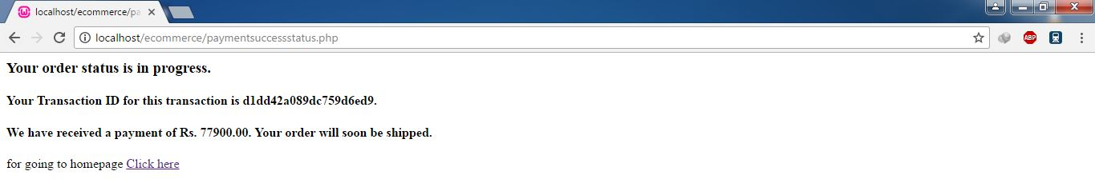

**Fig. 13: Payment Success**

**Payment Failure**

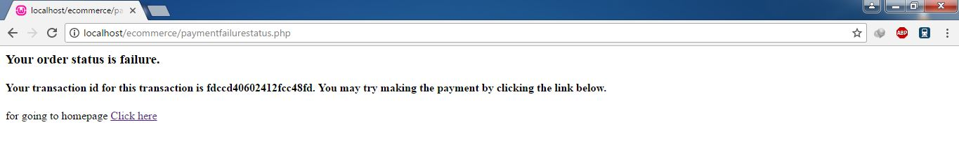

**Fig. 14: Payment Failure**

**Admin Area**

**Login**

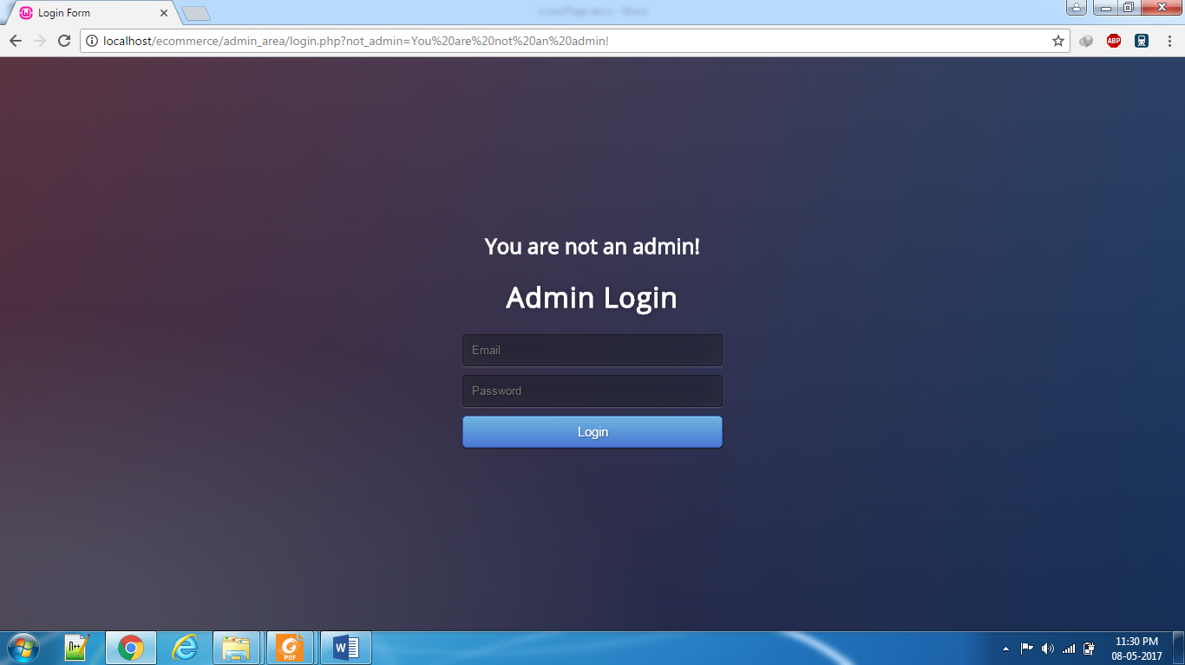

**Fig. 15: Admin Login**

**Index Page**

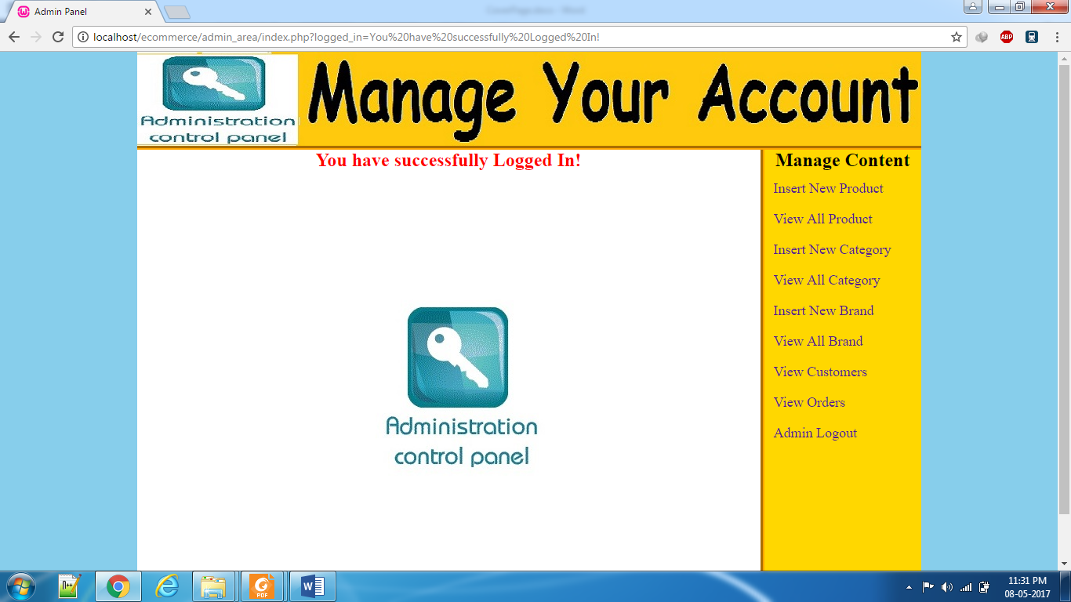

**Fig. 16: Admin Home Page**

**Insert New Product**

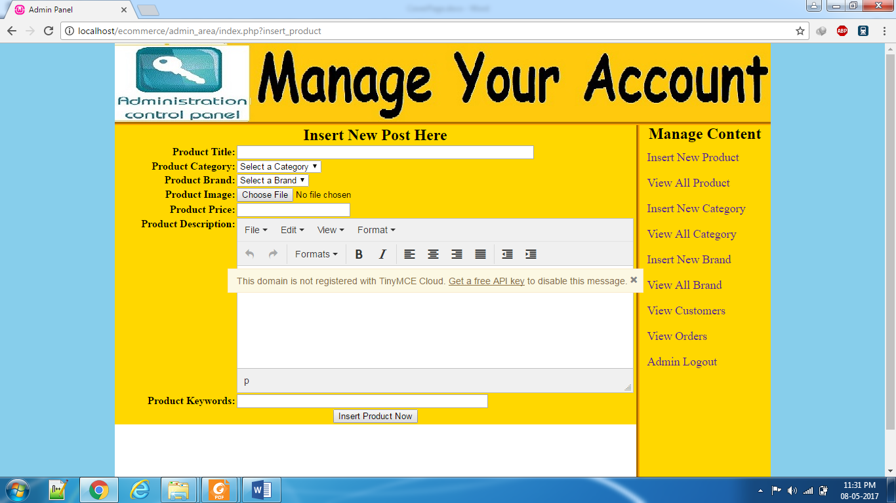

**Fig. 17: Insert new Product**

**View All Product**

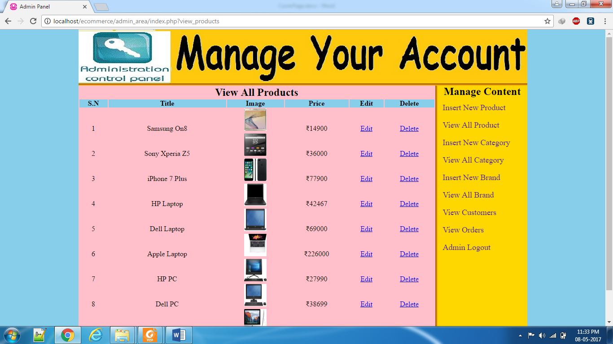

**Fig. 18: View all Product**

**Insert New Category**

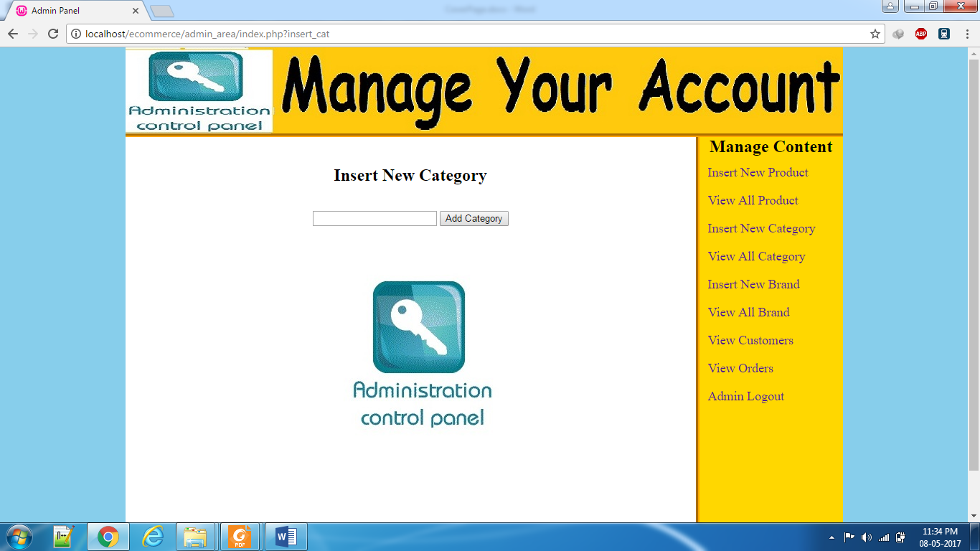

**Fig. 19: Insert New Product**

**View All Category**

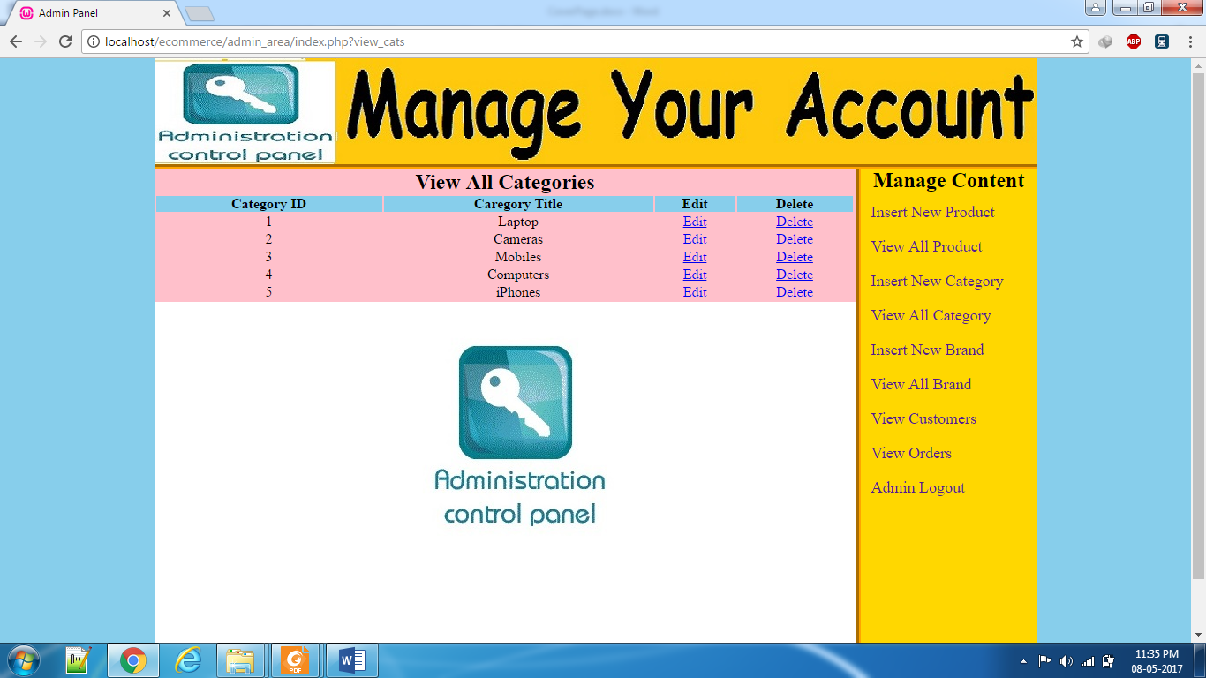

**Fig. 20: View All Categories**

**Insert New Brand**

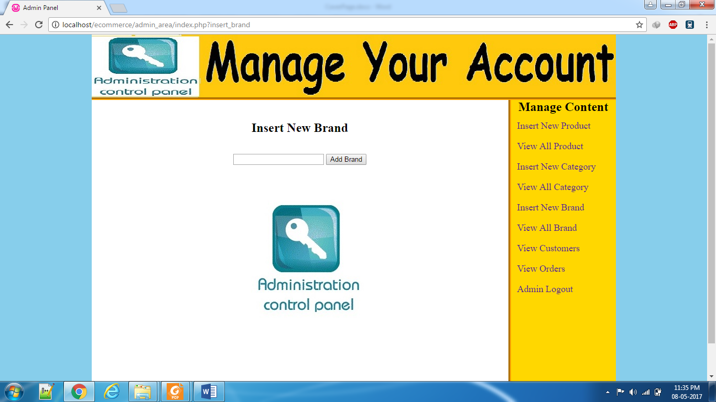

**Fig. 21: Insert New Brand**

**View All Brand**

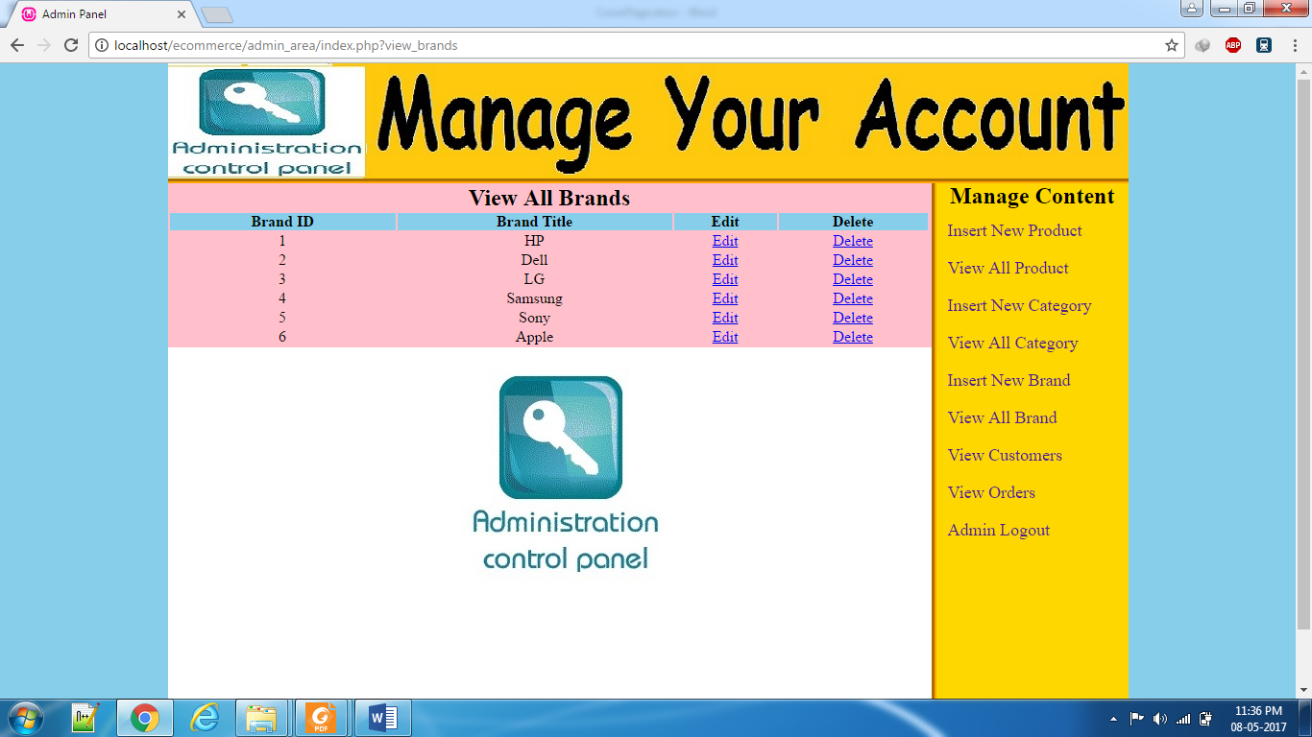

**Fig. 22: View all brand**

**View Customers**

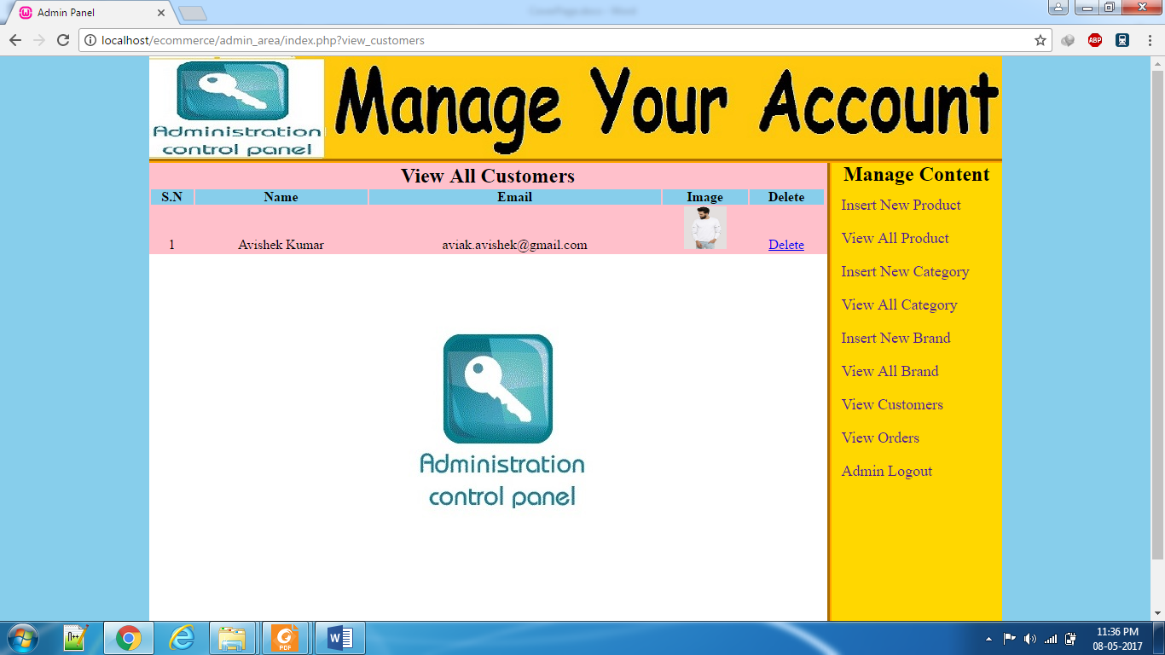

**Fig. 23: View Orders**

**View Orders**

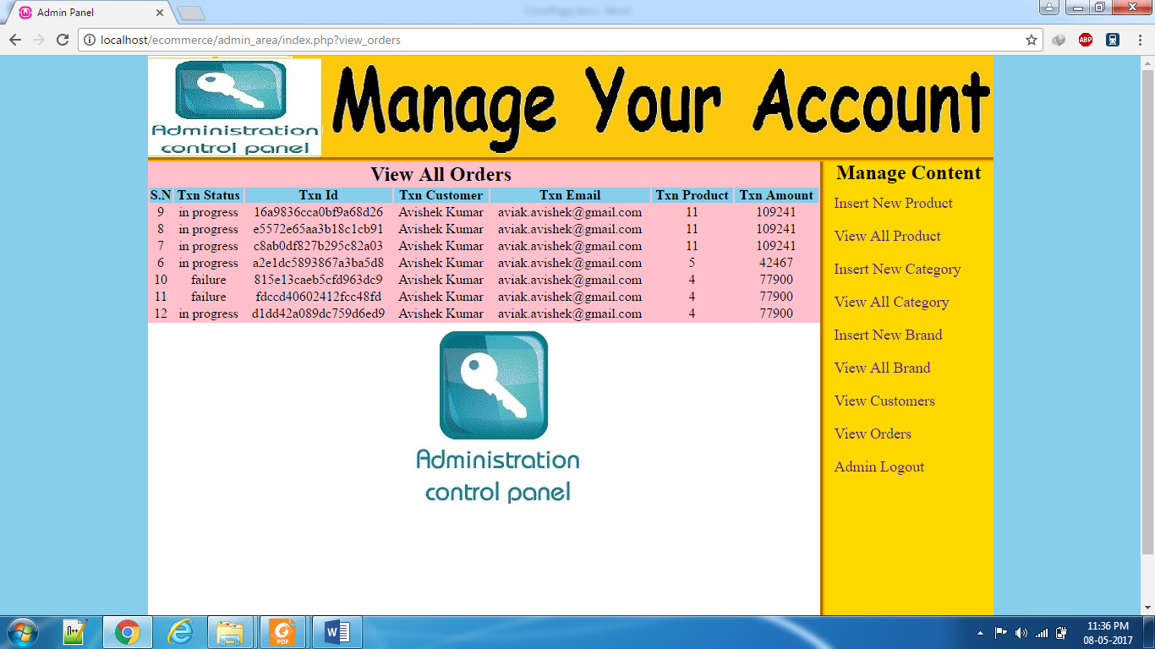

**Fig. 24: View All Orders**

## Test Cases

Test Cases: 1

Identifier: T1

Purpose: Test functionality of login form.

Test input/Data

|  |  |  |  |  |
| --- | --- | --- | --- | --- |
| **Test Data/ Action** | **Condition Description** | **Expected Result** | **Action Result** | **Remark** |
| T01: Email Id & password validation. | C1: Either Email id or password both wrong. | It should display Error message “Wrong Credentials”. | It displays error message “Wrong Credentials”. | Pass |
|  | C2: Enter null value for email id. | It should display Error message “Email id cannot be left blank”. | It displays Error message “Email id cannot be left blank”. | Pass |
|  | C3: Enter null value for password. | It should display error message “Password cannot be blank”. | It displays error message “password cannot be blank”. | Pass |
| T02: Submit | Click on submit. | It should validate the fields and navigate to proper page. | It validates the fields and navigate to proper page. | Pass |

**Table 10: Test Cases: 1**

Test Cases: 2

Identifier: T2

Purpose: Test functionality of registration form

Pre-requisite: Appropriate database with sample record should be ready.

Text Input/Data

|  |  |  |  |  |
| --- | --- | --- | --- | --- |
| **Test Data/ Action** | **Condition Description** | **Expected Result** | **Actual Result** | **Remark** |
| T01: Blank Form validation |  | Form should not be submitted & all the validation errors are displayed. | Form is not submitted & all the validation errors are displayed. | Pass |
| T02: Empty (Null Value) fields validation. | C1: Enter Null value for name. | It should display error message “mandatory fileds”. | It displays error message “mandatory fields”. | Pass |
|  | C2: Enter null value for password. | It should display error message “mandatory fileds”. | It displays error message “mandatory fields”. | Pass |
|  | C3. Enter null value for contact no. | It should display error message “mandatory fileds”. | It displays error message “mandatory fields”. | Pass |
|  | C4. Enter null value for email id. | It should display error message “email id cannot be left blank”. | It displays error message “email id cannot be left blank”. | Pass |
|  | C5. Enter null value for addresses. | It should display error message “mandatory fileds”. | It displays error message “mandatory fields”. | Pass |
| T03. Submit | Click on submit. | It should validate the fields and display data inserted. | It validates the fields and display data inserted. | Pass |

**Table 11: Test Cases: 2**

Test Cases: 3

Identifier: 3

Purpose: Check whether different hyperlinks are working properly or not.

|  |  |  |  |
| --- | --- | --- | --- |
| **Test Data/Action** | **Expected Result** | **Actual Result** | **Remark** |
| T01: click on Home page hyperlink menu. | Should display home page. | It displays home page. | Pass |
| T02: click on About us page hyperlink menu. | Should display about us page. | It displays about us page. | Pass |
| T03: click on any brand and category. | Should display respective data. | It displays respective data. | Pass |
| T04: Click on cart page hyperlink menu. | Should display cart page. | It displays cart page. | Pass |

**Table 12: Test Cases: 3**

Test Cases: 4

Identifier: T04

Purpose: Check whether the product purchase transaction by the Customer/shopkeeper takes place smoothly.

Pre-requisite: Appropriate database with sample record should be ready.

|  |  |  |  |  |
| --- | --- | --- | --- | --- |
| Test Data/Action | Condition Description | Expected Result | Actual Result | Remark |
| T01: add to cart. | Click add to cart button. | It should open cart page & add product to cart. | It opens cart page & add products to cart. | Pass |
| T02: Products with total amount, cost. | Click on checkout button | It should go to payment page. | It goes to payment page. | Pass |
| T03: Place order. | Click on place order button. | It should generate bill. | It generates bill. | Pass |

**Table 13: Test Cases: 4**

## Maintenance and Evaluation

### System Maintenance and future enhancement

**System Maintenance:**

Once the website is delivered and deployed, then maintenance phase starts. Website requires maintenance because there are some residual errors remaining in the system that must be removed as they are discovered.

They have taken annual contract to us for regular website check-ups. In Maintenance we will be doing the following:

* Fixing bugs if at all anything found during actual working.
* Any minor changes that is required when the client working with it will be done.
* Periodic checking of website at regular intervals.
* Make better use of existing tools and techniques.
* Online technical support at any instance of time.

**Future Enhancement:**

Nothing can be ended in a single step. It is the fact that nothing is permanent in this world. So this project also has some future enhancements in the evergreen and booming IT industry.

Further enhancement of the software will have the following features:

* Bill generation will be incorporated which will keep track of all the expense, income  
  obtained each month and many more.
* A web application will be developed that will make bill generation faster and on the  
  go. Customer/shopkeeper will not have to visit the shop personally.

### User Manual

Since this a customized software it is designed as per the user requirement and suggestions most of the stuff are known to user.

Admin side:

How to add/remove customers/shopkeeper, shopkeepers?

1. Go to the admin page and login with the name and password.
2. There you will find a menu bar that displays customer/shopkeeper, shopkeeper,  
   distributor.
3. Click on edit, update, delete button as per admin needs.
4. Now click on working with existing society and in that select the society for which  
   you want to print the bill and receipt.
5. Now you will find print bill and receipt button click on it and select the month and  
   year and then click on print.

How to approve an order of the customer/shopkeeper?

1. Go to the admin page and login with credentials.
2. There you will find a menu bar that displays approve.
3. Click on it.
4. And click on approve button according to admin wishes.

# Conclusion and Future Scope

The eCommerce industry in India may currently be behind its counterparts in a number of developed countries and even some emerging markets. However, with India’s GDP growth pegged at 6.4% by the International Monetary Fund and the World Bank, it is expected to grow rapidly. Moreover, the Indian eCommerce industry has access to funds from within the country and international investors. Overall, the eCommerce sector is maturing and a number of serious players are entering the market. What differentiates the Indian eCommerce market from that of a country like China is that while market concentration in China is largely on account of Alibaba-owned Taobao and Tmall (with these players holding a higher percentage of market share than the top players in most of the other major markets), in India the market share is divided amongst several ecommerce companies, each coming up with its own business model. As a result, customers have a wide range of products and services to choose from.

In our view, there is humongous potential for eCommerce companies owing to the growing internet user base and advancements in technology. However, this will not be without its share of challenges, be it operational, regulatory, or digital. How a company prepares itself to meet these challenges will decide whether or not it succeeds.

# References

1. <https://www.tutorialspoint.com/>
2. <http://www.youtube.com/>
3. <http://www.w3schools.com/>
4. <http://stackoverflow.com/>
5. <http://php.net/>
6. <https://www.mysql.com/>
7. [www.quora.com](http://www.quora.com).
8. www.wampserver.com.

1. Definition on Wikipedia.
2. Definition on quora.com.
3. Source Wikipedia.
4. Source: www.wampserver.com.
5. Source: www.w3schools.com.